4. Fit Line
In our experiments we have some different values often does not match each other. However, we have to find an equation of the correlation between two factors. Thus, we draw a line called fit line to represent average trend between two values. In this experiment we should represent the correlation between acceleration and kinetic friction coefficient values.

I use numpy and matplotlib modules in Python to draw a graph and find the equation of fit line fit line of acceleration and kinetic friction coefficient values. First I plot the values of steel ball at the first level of projectile launcher on the graph.

import numpy as np
import matplotlib.pyplot as plt

#define accelerations and kinetic friction coefficients data
angles = np.array([30, 30, 30, 45, 45, 45, 60, 60, 60])
ranges = np.array([350, 420, 410, 480, 485, 486, 390, 430, 425])

#add points to plot
plt.scatter(angles, ranges, color='steelblue')

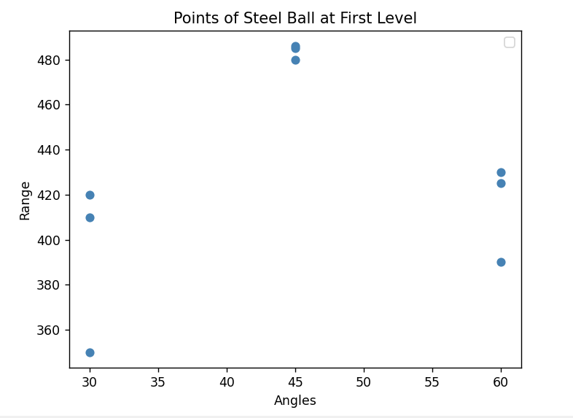

1. Graph 1: Values of Acceleration and Kinetic Friction Coefficient Values
Second, I find the fit line equation “f(x) = mx + n” using polyfit() function of numpy module then, I plot the fit line using plot() function of matplotlib module.

#find fit line
m, n = np.polyfit(angles, ranges, 1)

#add fit line to plot
plt.plot(angles, m*angles+n, color='red', linewidth=2, label= 'Fit line: ' + 'f(x) = ' + '{:.3f}'.format(m) + 'x' + ' + {:.3f}'.format(n)

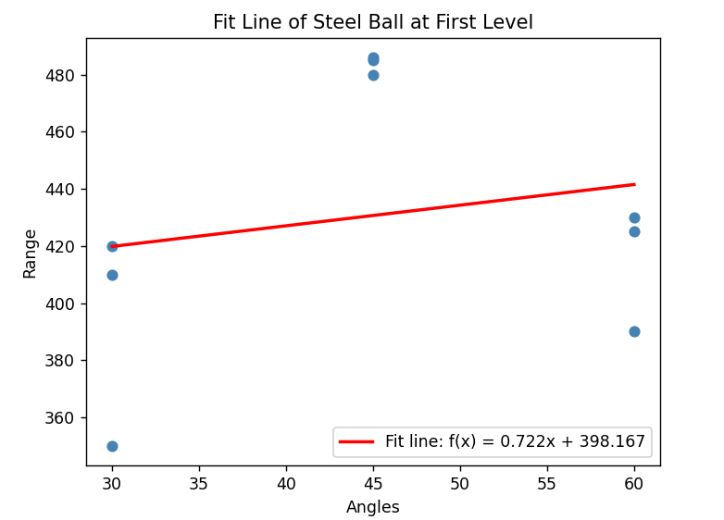
2. Graph 2: Fit Line of Angles and Range Values Steel Ball at Level 1

All of the graphs I made in this experiment , I use the method that I used in the graph above also I changed variable names and values only on the further codes.
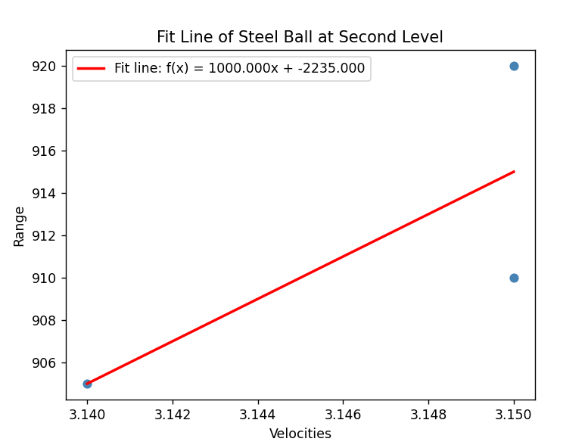
3. Graph 3: Fit Line of Velocities and Range Values of Steel Ball at Level 2

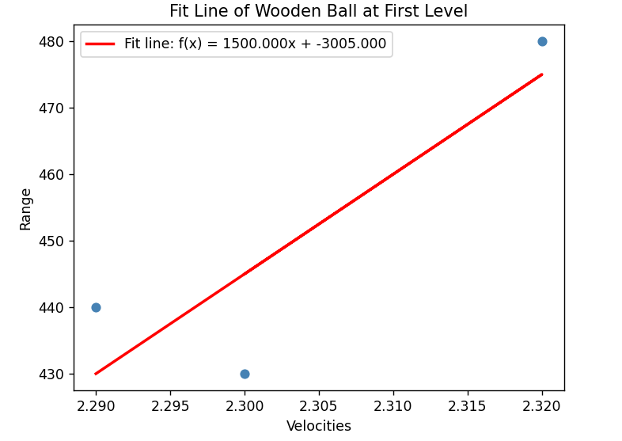
4. Graph 4: Fit Line of Velocities and Range Values of Wooden Ball

Source Code:
import numpy as np
import matplotlib.pyplot as plt

#define accelerations and kinetic friction coefficients data
angles = np.array([30, 30, 30, 45, 45, 45, 60, 60, 60])
ranges = np.array([350, 420, 410, 480, 485, 486, 390, 430, 425])

#find fit line
m, n = np.polyfit(angles, ranges, 1)

#add points to plot
plt.scatter(angles, ranges, color='steelblue')

#add fit line to plot
plt.plot(angles, m*angles+n, color='red', linewidth=2, label= 'Fit line: ' + 'f(x) = ' + '{:.3f}'.format(m) + 'x' + ' + {:.3f}'.format(n))

plt.xlabel('Angles')
plt.ylabel('Range')
plt.title('Fit Line of Steel Ball at First Level')

plt.legend()
plt.show()

